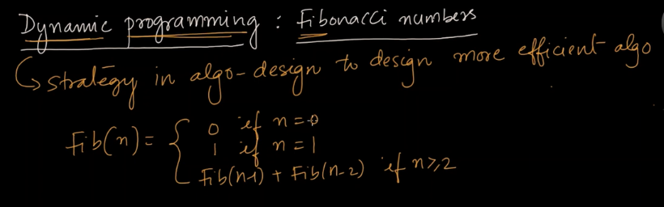

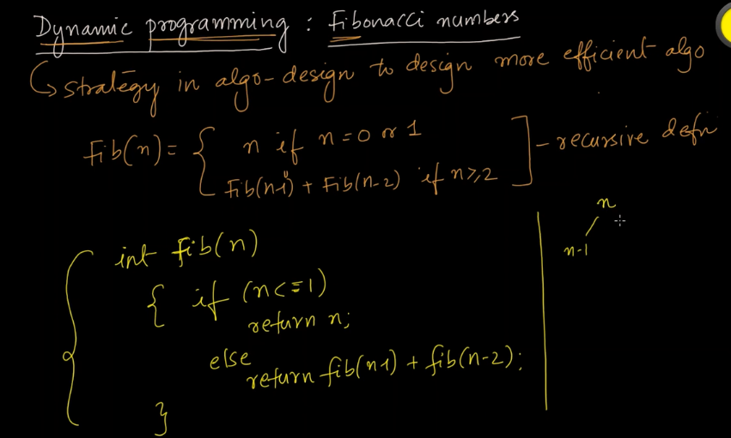

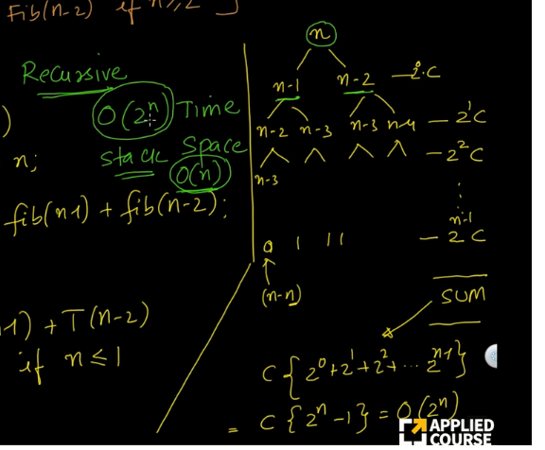

time complexity is very very high.

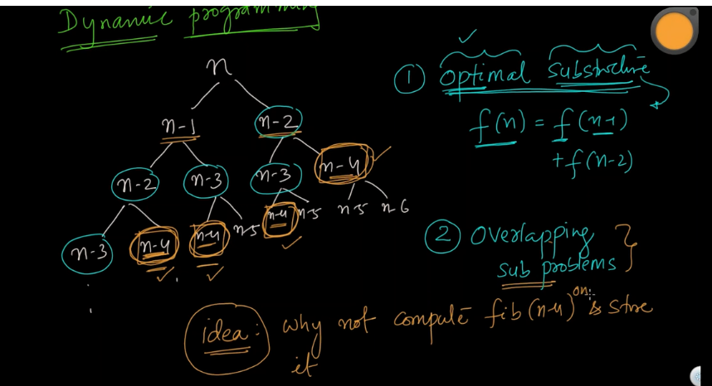

It has optimal substructure where the problem will be divided by the subproblem with the same function with lesser value.

The larger problem can be solved by the subproblems of the large problem.

Overlapping subproblem means we will calcualate the values of n-4,n-5,n-3 and store it and use it later.

Dynamic Programming should satisfy the above two properties.

There are two types of Dynamic Programming.

1)Top Down

2)Bottom Up

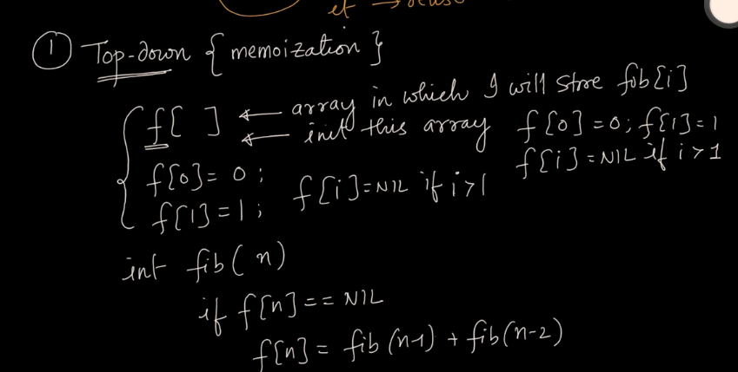

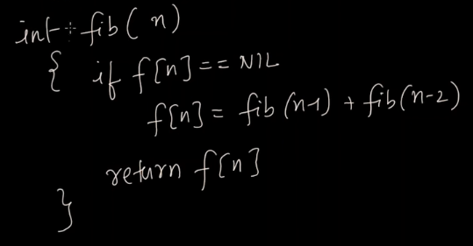

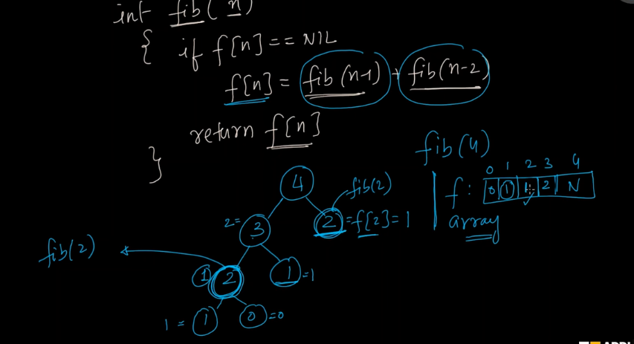

I will store the values in the array and use it when required in the left tree. We dont need to calcualate it everytime.

Memoziation:- Means stroing the intermediate results in an array and use it whenever required.

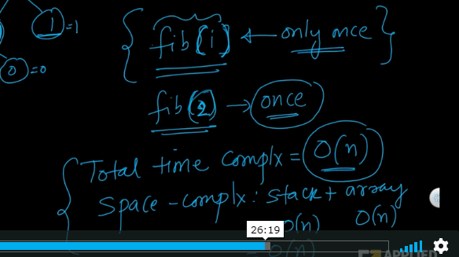

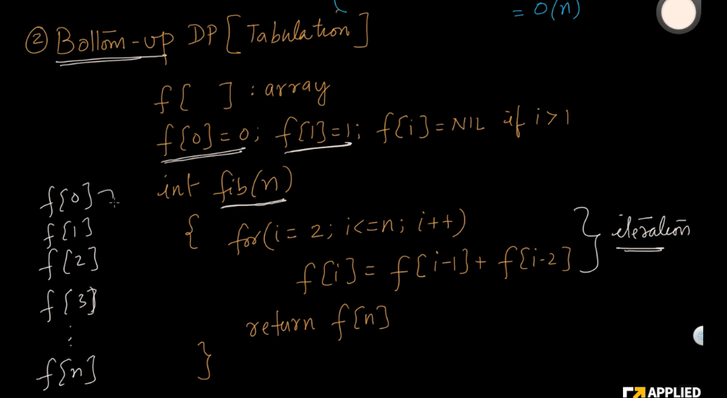

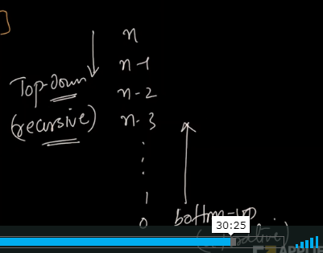

Bottom up is iterative.

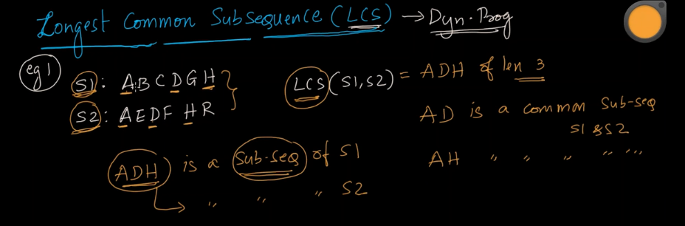

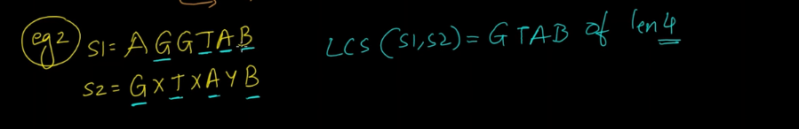

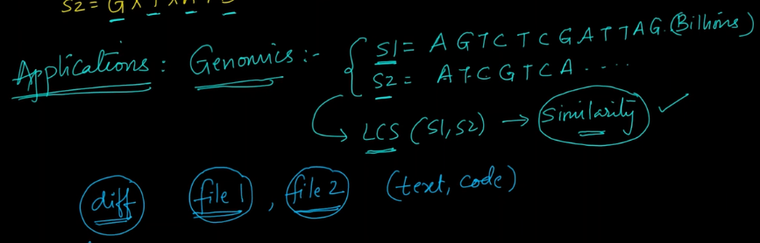

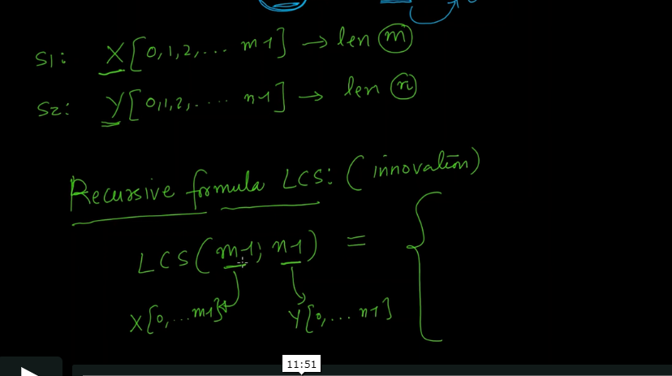

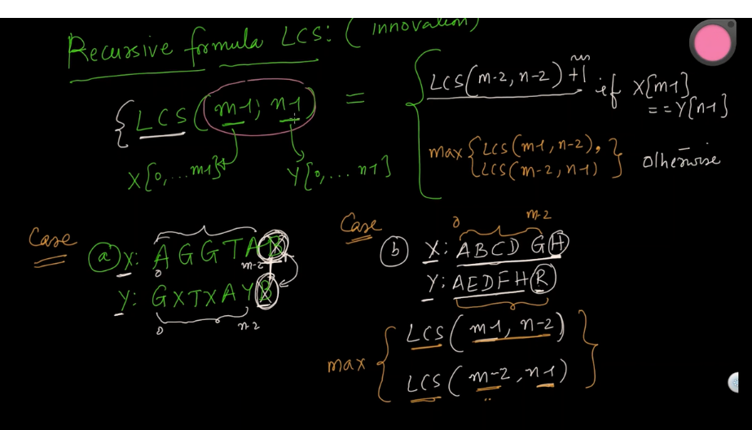

Here m-1 is the whole length of x.

n-2 is the entire y except the last character because last character is not matching here.

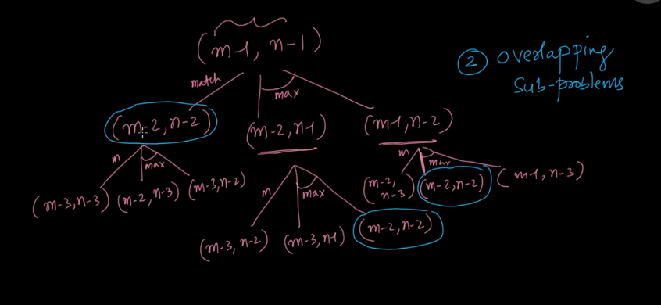

the recursive tree is shown as above.

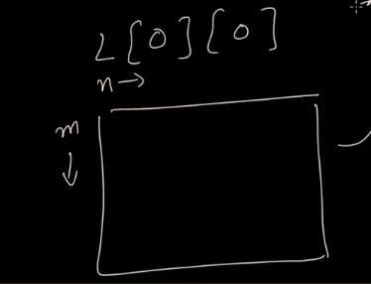

So i can store the results in two dimensional array where m=first string and n=second substring.

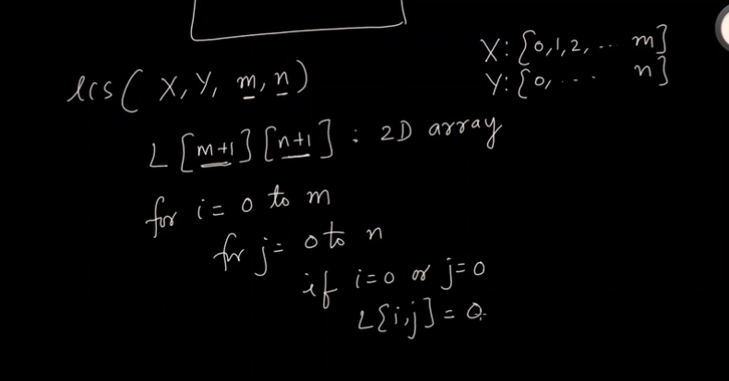

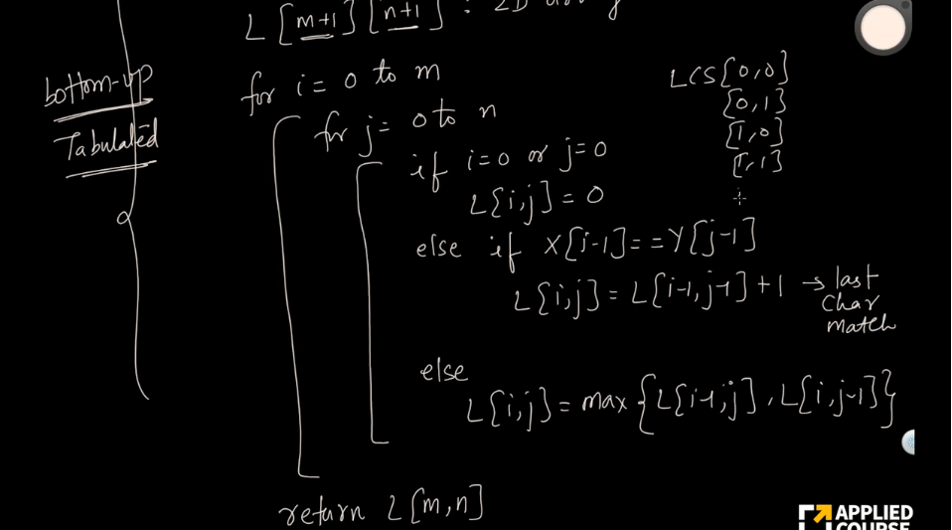

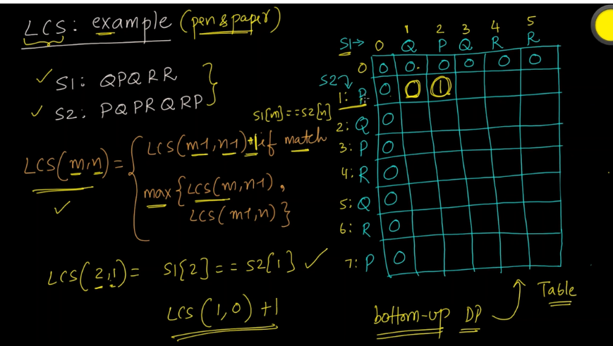

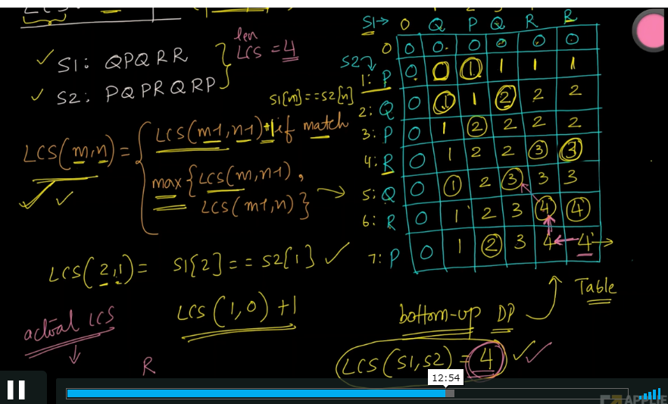

Code:-

1. **def** lcs_algo(S1, S2, m, n):
2. L = [[0 **for** x **in** range(n+1)] **for** x **in** range(m+1)]
4. *# Building the mtrix in bottom-up way*
5. **for** i **in** range(m+1):
6. **for** j **in** range(n+1):
7. **if** i == 0 **or** j == 0:
8. L[i][j] = 0
9. **elif** S1[i-1] == S2[j-1]:
10. L[i][j] = L[i-1][j-1] + 1
11. **else**:
12. L[i][j] = max(L[i-1][j], L[i][j-1])
14. index = L[m][n]
16. lcs_algo = [""] * (index+1)
17. lcs_algo[index] = ""
19. i = m
20. j = n
21. **while** i > 0 **and** j > 0:
23. **if** S1[i-1] == S2[j-1]:
24. lcs_algo[index-1] = S1[i-1]
25. i -= 1
26. j -= 1
27. index -= 1
29. **elif** L[i-1][j] > L[i][j-1]:
30. i -= 1
31. **else**:
32. j -= 1
34. *# Printing the sub sequences*
35. **print**("S1 : " + S1 + "**\n**S2 : " + S2)
36. **print**("LCS: " + "".join(lcs_algo))

39. S1 = "ACADB"
40. S2 = "CBDA"
41. m = len(S1)
42. n = len(S2)
43. lcs_algo(S1, S2, m, n)

Success [#stdin](https://ideone.com/qi1QBh#stdin) [#stdout](https://ideone.com/qi1QBh#stdin) 0.01s 7048KB

[comments (0)](https://ideone.com/qi1QBh#comments)

 stdin

 copy

Standard input is empty

 stdout

 copy

S1 : ACADB

S2 : CBDA

LCS: CB

s

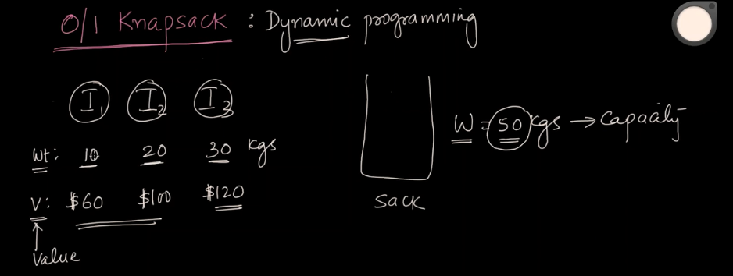

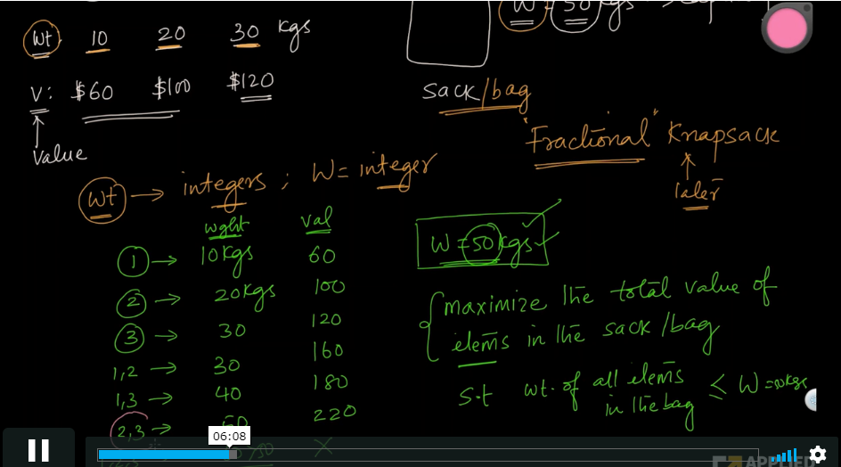

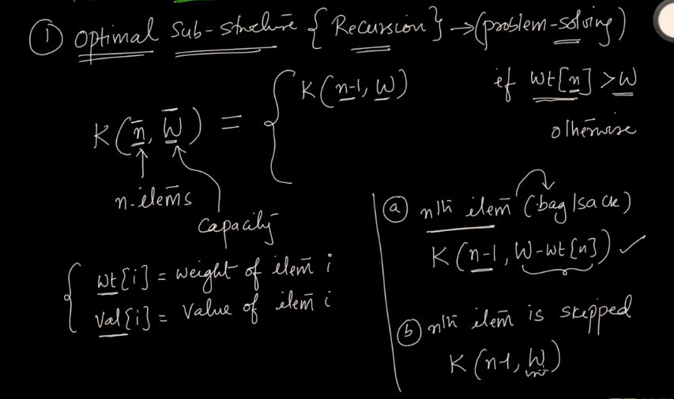

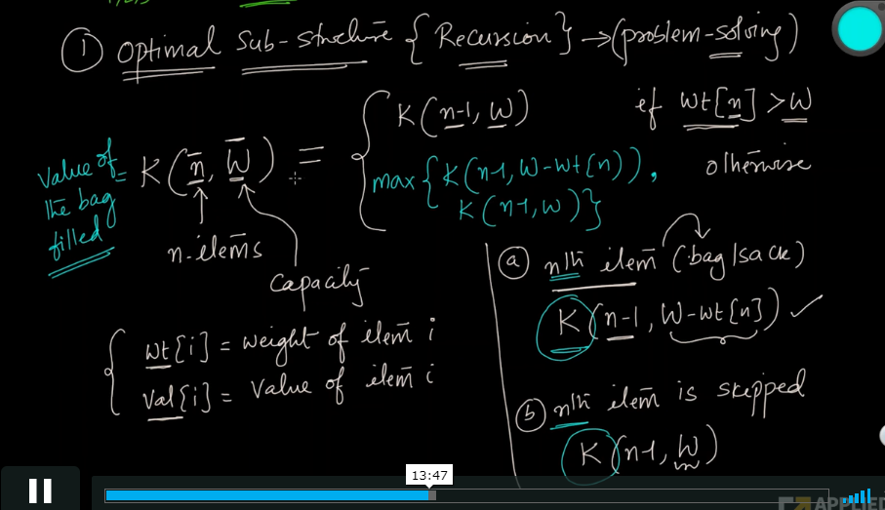

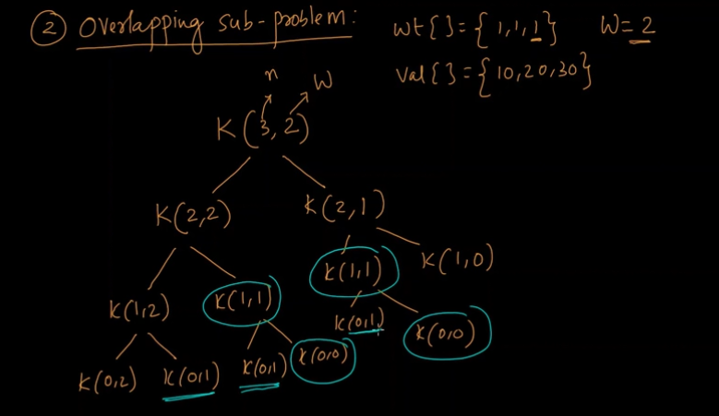

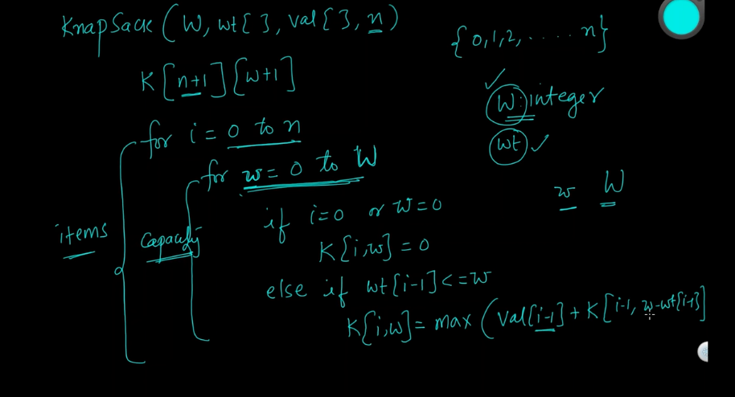

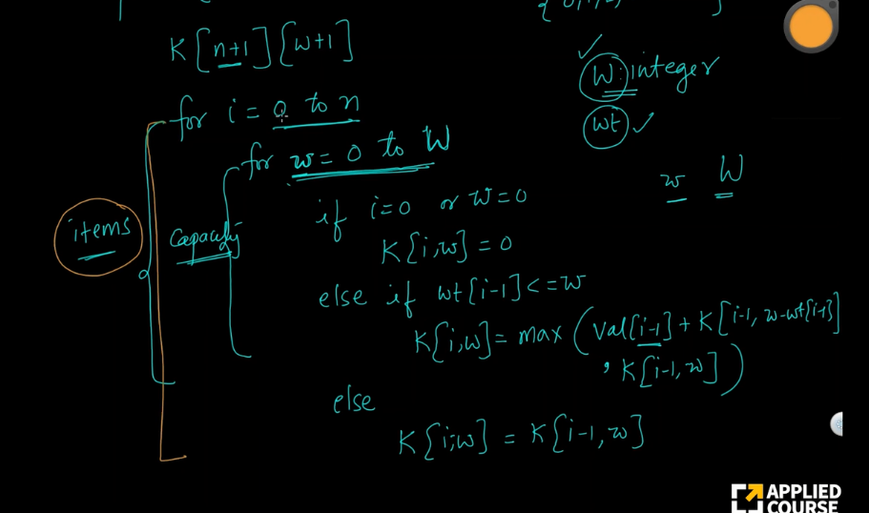

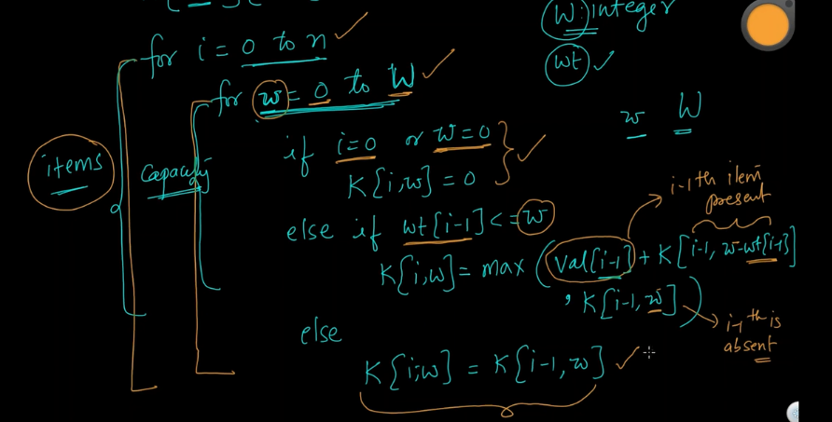

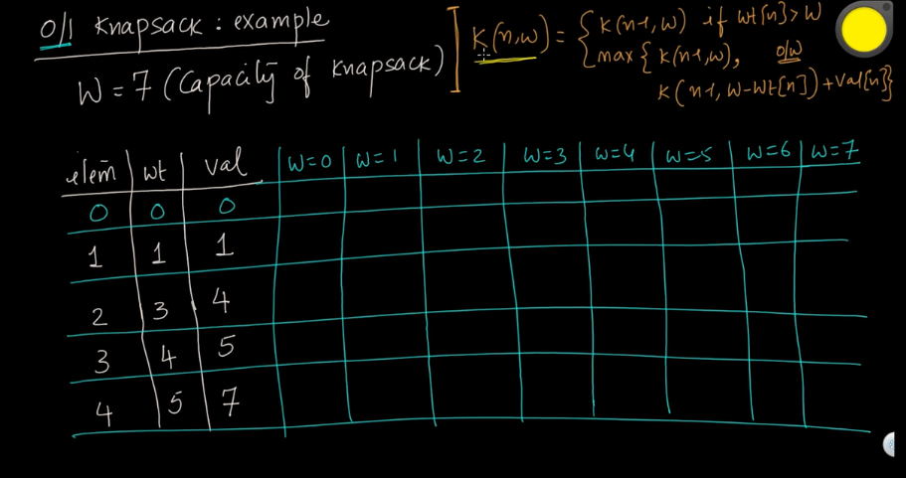

Code:-

1. *# Values (stored in list v)*
2. *# Weights (stored in list w)*
3. *# Number of distinct items (n)*
4. *# Knapsack capacity W*
5. **def** knapSack(v, w, n, W):
7. *# base case: Negative capacity*
8. **if** W < 0:
9. **return** float('-inf')
11. *# base case: no items left or capacity becomes 0*
12. **if** n < 0 **or** W == 0:
13. **return** 0
15. *# Case 1. include current item n in Knapsack (v[n]) and recur for*
16. *# remaining items (n - 1) with decreased capacity (W - w[n])*
17. include = v[n] + knapSack(v, w, n - 1, W - w[n])
19. *# Case 2. exclude current item n from Knapsack and recur for*
20. *# remaining items (n - 1)*
21. exclude = knapSack(v, w, n - 1, W)
23. *# return maximum value we get by including or excluding current item*
24. **return** max(include, exclude)

27. *# 0-1 Knapsack problem*
28. **if** __name__ == '__main__':
30. *# Input: set of items each with a weight and a value*
31. v = [20, 5, 10, 40, 15, 25]
32. w = [1, 2, 3, 8, 7, 4]
34. *# Knapsack capacity*
35. W = 10
37. **print**("Knapsack value is", knapSack(v, w, len(v) - 1, W))

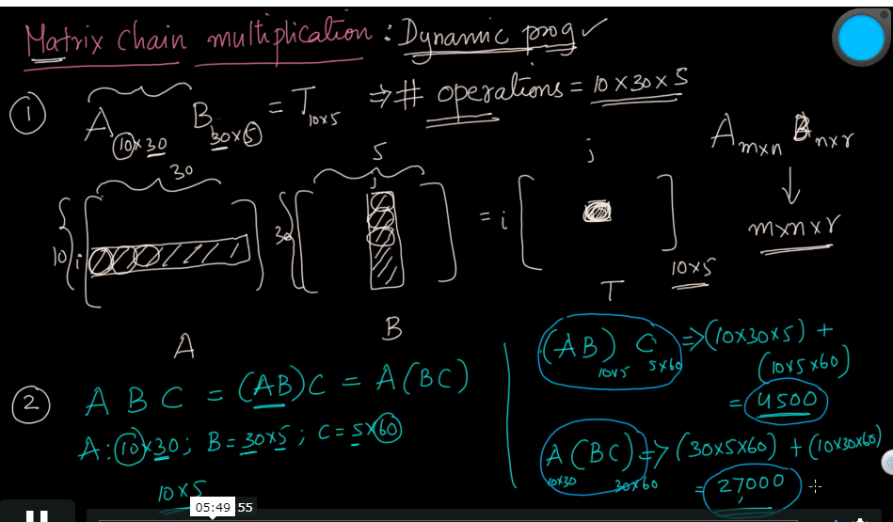

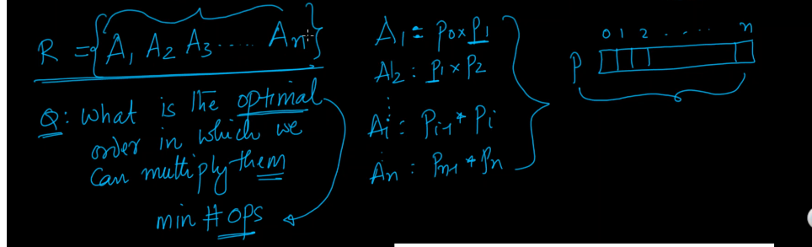

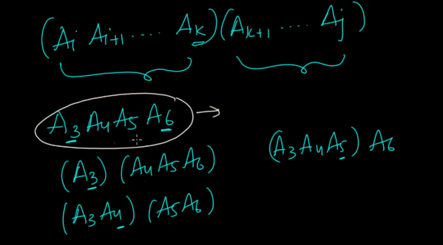

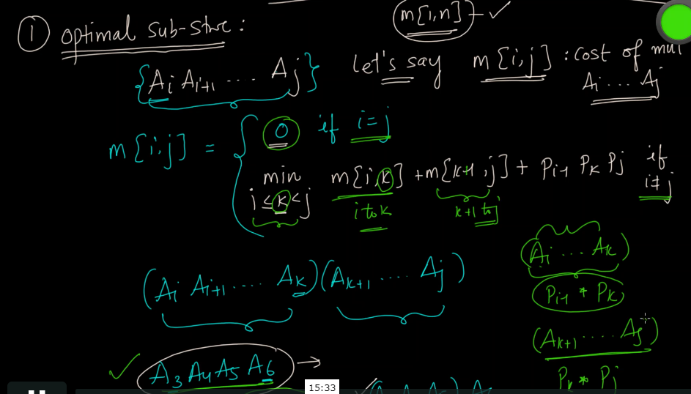

Here in the above screenshot, i=j means there is only one matrix. So we are multiply the matrix with anyone else as there is only one matrix. That’s why the cost is 0 here.

Pj-1PkPj is the cost of multiplication of the resultant matrix that we get from m[i,k] and m[k+1,j].

These are the resultant mtrix that we will be getting by getting the optimal k value which minimizes the

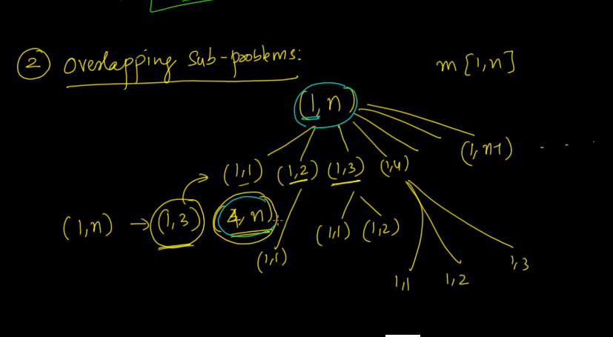

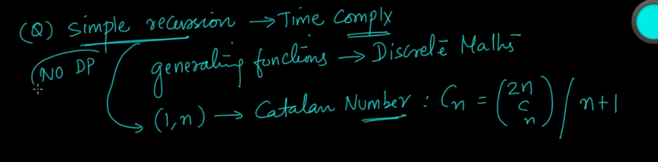

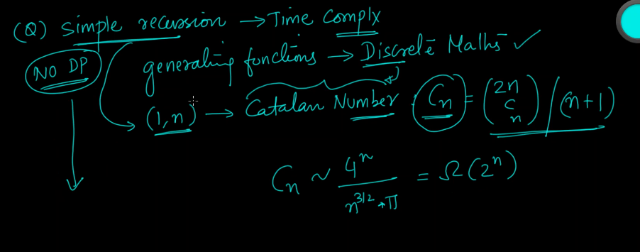

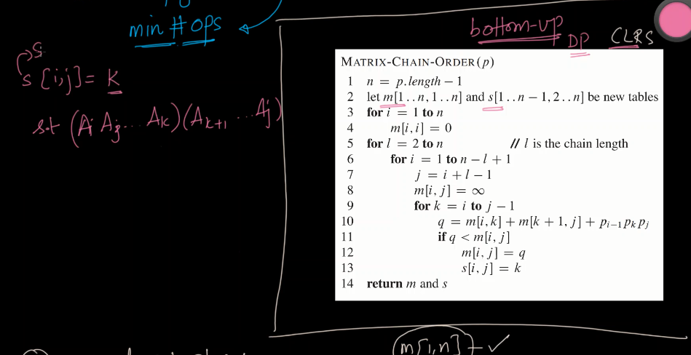

In the matrix, S[i,j], we are storing the optimal value of K where i am splitting the multiplication.

*Given an array p[] which represents the chain of matrices such that the ith matrix Ai is of dimension p[i-1] x p[i]. We need to write a function MatrixChainOrder() that should return the minimum number of multiplications needed to multiply the chain.*

**Input: p[] = {40, 20, 30, 10, 30}**

**Output: 26000**

There are 4 matrices of dimensions 40x20, 20x30, 30x10 and 10x30.

Let the input 4 matrices be A, B, C and D. The minimum number of

multiplications are obtained by putting parenthesis in following way

(A(BC))D --> 20*30*10 + 40*20*10 + 40*10*30

**Input: p[] = {10, 20, 30, 40, 30}**

**Output: 30000**

There are 4 matrices of dimensions 10x20, 20x30, 30x40 and 40x30.

Let the input 4 matrices be A, B, C and D. The minimum number of

multiplications are obtained by putting parenthesis in following way

((AB)C)D --> 10*20*30 + 10*30*40 + 10*40*30

**Input: p[] = {10, 20, 30}**

**Output: 6000**

There are only two matrices of dimensions 10x20 and 20x30. So there

is only one way to multiply the matrices, cost of which is 10*20*30

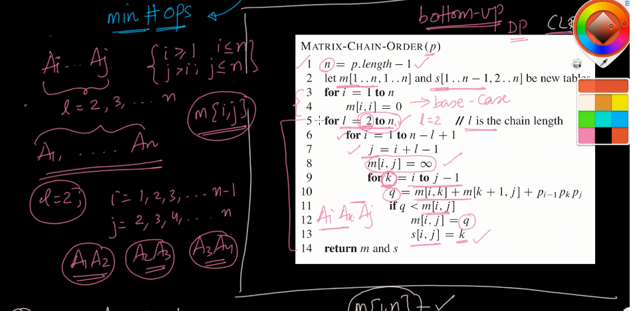

Here l means we are splitting the matrix with a group of 2.

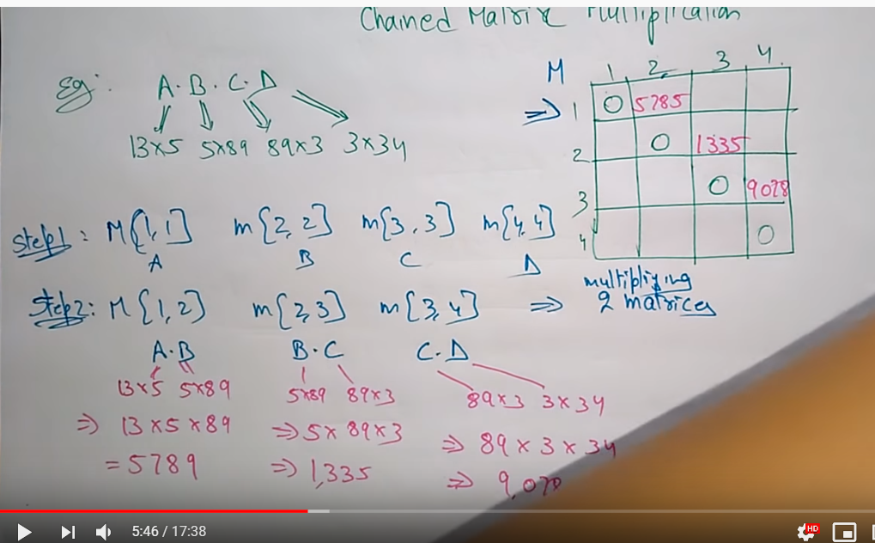

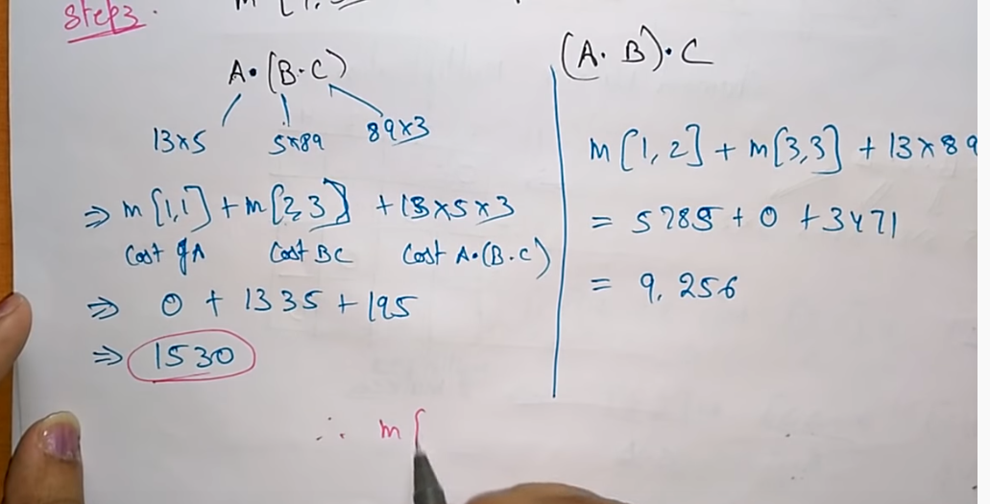

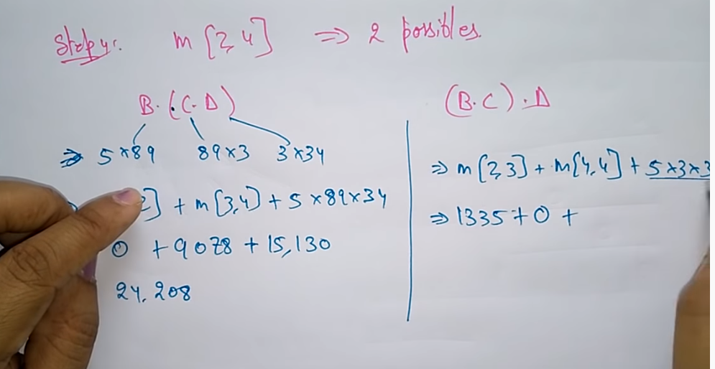

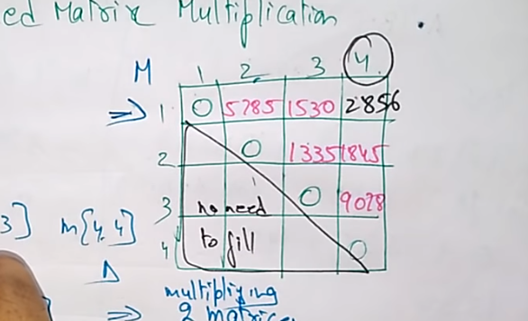

Code:-

1. *# Function to find the most efficient way to multiply*
2. *# given sequence of matrices*
3. **def** MatrixChainMultiplication(dims, i, j):
5. *# base case: one matrix*
6. **if** j <= i + 1:
7. **return** 0
9. *# stores minimum number of scalar multiplications (i.e., cost)*
10. *# needed to compute the matrix M[i+1]...M[j] = M[i..j]*
11. min = float('inf')
13. *# take the minimum over each possible position at which the*
14. *# sequence of matrices can be split*
16. """
17. (M[i+1]) x (M[i+2]..................M[j])
18. (M[i+1]M[i+2]) x (M[i+3.............M[j])
19. ...
20. ...
21. (M[i+1]M[i+2]............M[j-1]) x (M[j])
22. """
24. **for** k **in** range(i + 1, j):
26. *# recur for M[i+1]..M[k] to get an i x k matrix*
27. cost = MatrixChainMultiplication(dims, i, k)
29. *# recur for M[k+1]..M[j] to get a k x j matrix*
30. cost += MatrixChainMultiplication(dims, k, j)
32. *# cost to multiply two (i x k) and (k x j) matrix*
33. cost += dims[i] * dims[k] * dims[j]
35. **if** cost < min:
36. min = cost
38. *# return min cost to multiply M[j+1]..M[j]*
39. **return** min

42. **if** __name__ == '__main__':
44. *# Matrix M[i] has dimension dims[i-1] x dims[i] for i = 1..n*
45. *# input is 10 × 30 matrix, 30 × 5 matrix, 5 × 60 matrix*
46. dims = [10, 30, 5, 60]
48. **print**("Minimum cost is", MatrixChainMultiplication(dims, 0, len(dims) - 1))

Success [#stdin](https://ideone.com/6pFgOL#stdin) [#stdout](https://ideone.com/6pFgOL#stdin) 0.01s 7320KB

[comments (0)](https://ideone.com/6pFgOL#comments)

 stdin

 copy

Standard input is empty

 stdout

 copy

('Minimum cost is', 4500)

ss

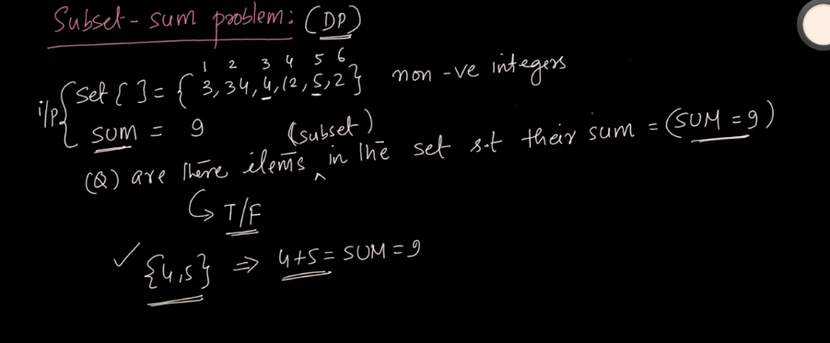

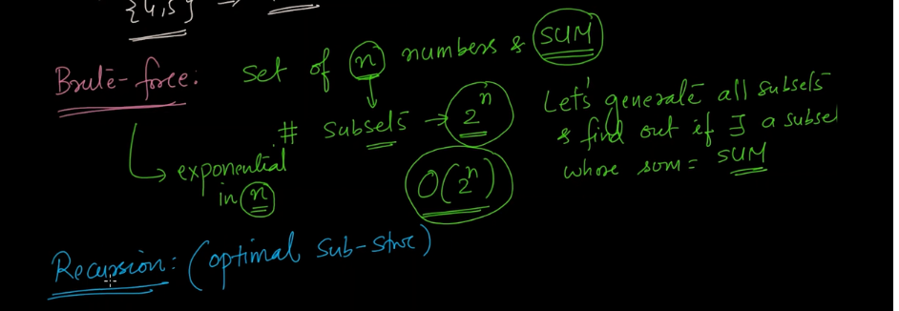

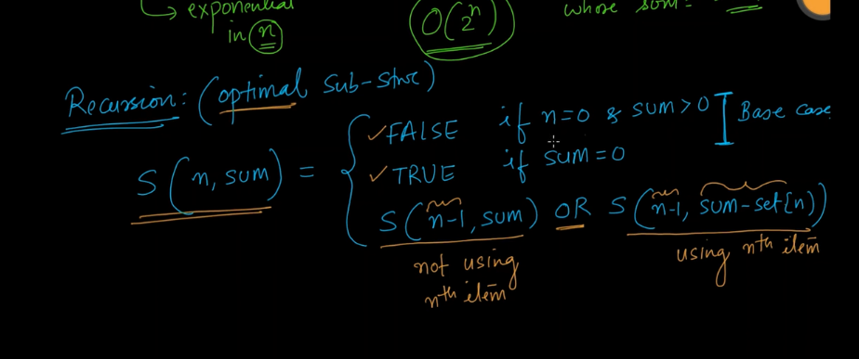

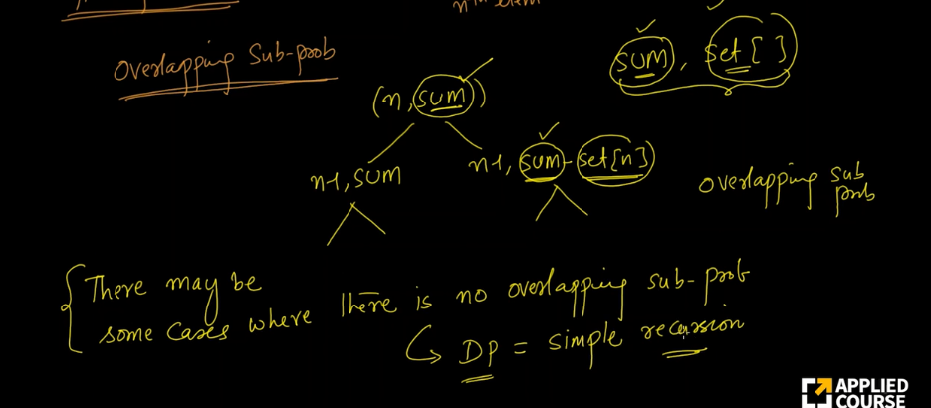

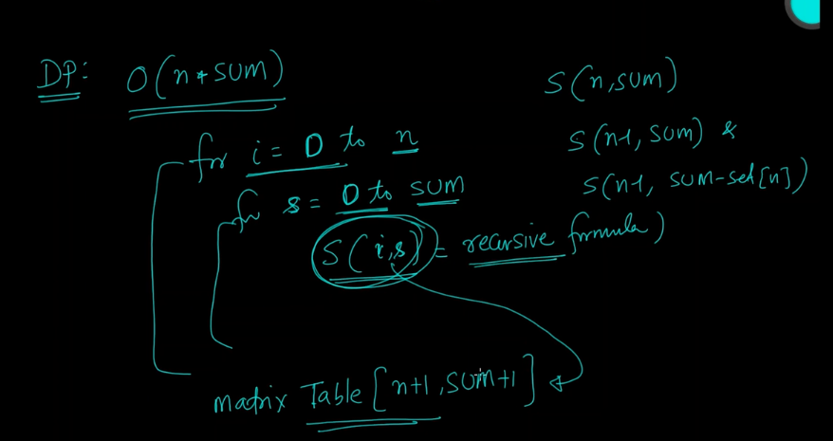

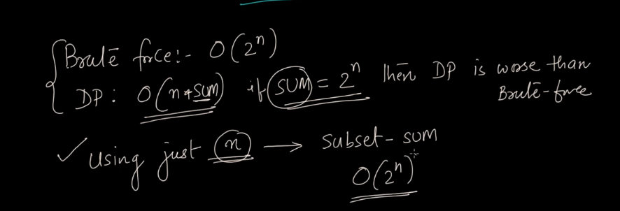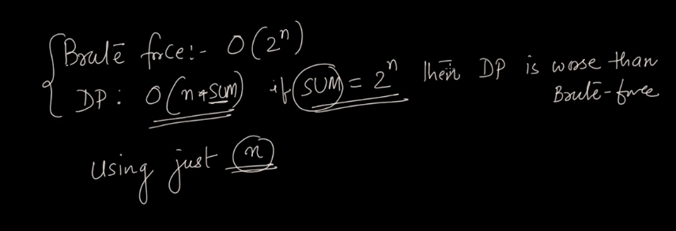

1. *# Return true if there exists a subsequence of A[0..n] with given sum*
2. **def** subsetSum(A, n, sum):
4. *# return true if sum becomes 0 (subset found)*
5. **if** sum == 0:
6. **return** True
8. *# base case: no items left or sum becomes negative*
9. **if** n < 0 **or** sum < 0:
10. **return** False
12. *# Case 1. include current item in the subset (A[n]) and recur*
13. *# for remaining items (n - 1) with remaining sum (sum - A[n])*
14. include = subsetSum(A, n - 1, sum - A[n])
16. *# Case 2. exclude current item n from subset and recur for*
17. *# remaining items (n - 1)*
18. exclude = subsetSum(A, n - 1, sum)
20. *# return true if we can get subset by including or excluding the*
21. *# current item*
22. **return** include **or** exclude

25. *# Subset Sum Problem*
26. **if** __name__ == '__main__':
28. *# Input: set of items and a sum*
29. A = [7, 3, 2, 5, 8]
30. sum = 14
32. **print**("Yes" **if** subsetSum(A, len(A) - 1, sum) **else** "No")

Success [#stdin](https://ideone.com/bqrXGJ#stdin) [#stdout](https://ideone.com/bqrXGJ#stdin) 0.01s 7064KB

[comments (0)](https://ideone.com/bqrXGJ#comments)

 stdin

 copy

Standard input is empty

 stdout

 copy

Yes

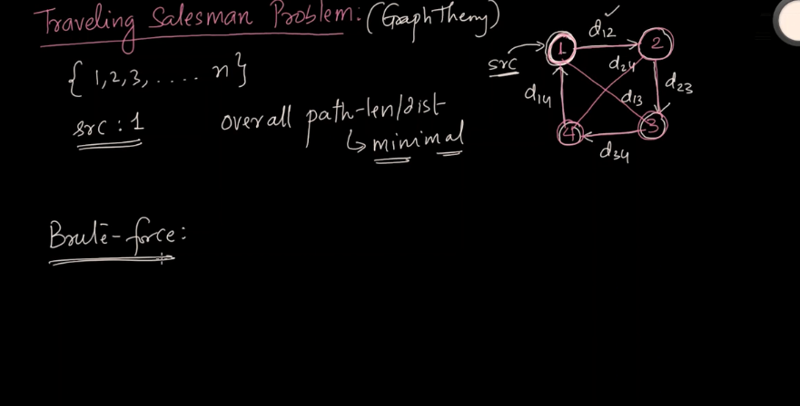

Here we need to touch every city and come back to the source.

[Travelling Salesman Problem (TSP) :](https://www.geeksforgeeks.org/travelling-salesman-problem-set-1/) Given a set of cities and distances between every pair of cities, the problem is to find the shortest possible route that visits every city exactly once and returns to the starting point.

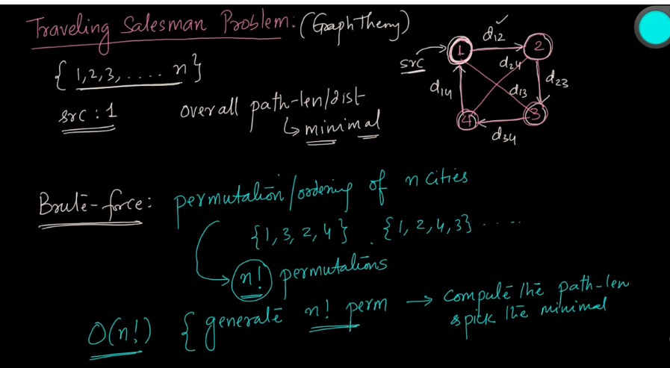

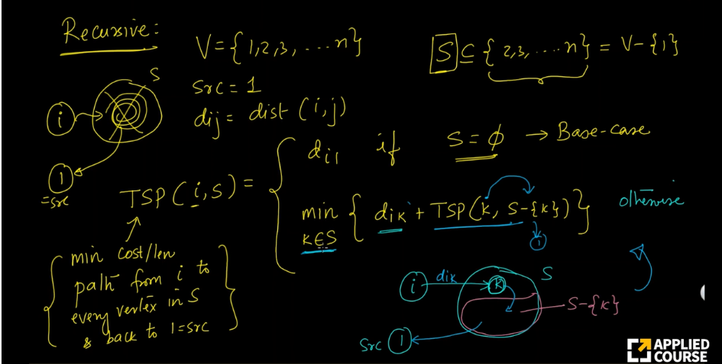

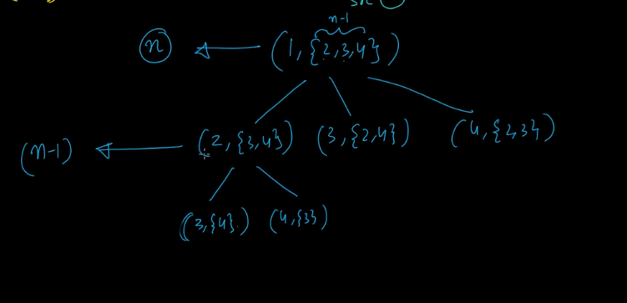

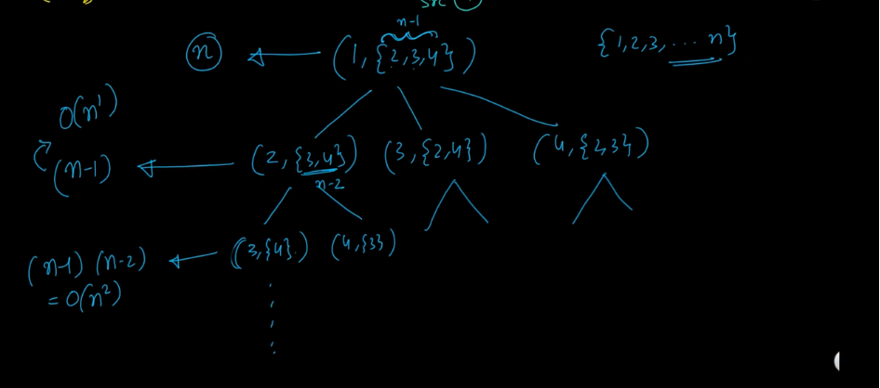

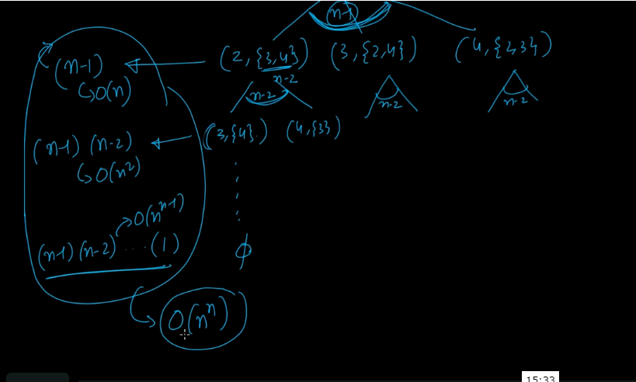

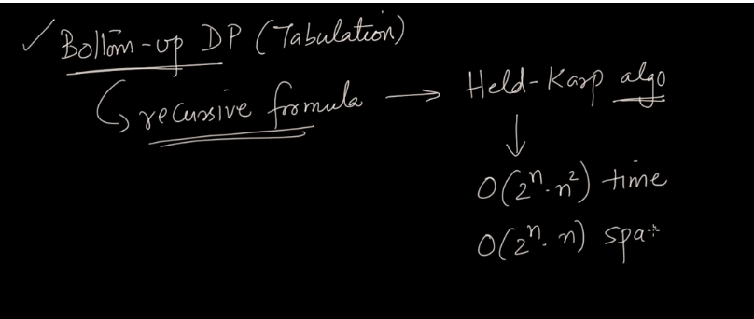

INT_MAX = 999999

n=4

dist= [

[0,20,42,25],

[20,0,30,34],

[42,30,0,10],

[25,34,10,0]

]

VISITED_ALL = (1<<n) -1;

dp = [[-1 for i in range(4)] for j in range(16)]

def tsp(mask,pos):

if(mask==VISITED_ALL):

return dist[pos][0]

if(dp[mask][pos]!=-1):

return dp[mask][pos]

ans = INT_MAX

for city in range(n):

if((mask&(1<<city))==0):

newAns = dist[pos][city] + tsp( mask|(1<<city), city)

ans = min(ans, newAns)

dp[mask][pos] = ans

return ans

print("Travelling Saleman Distance is",end = " ")

print(tsp(1,0))

**Largest Sum Contiguous Subarray**

Write an efficient program to find the sum of contiguous subarray within a one-dimensional array of numbers which has the largest sum.

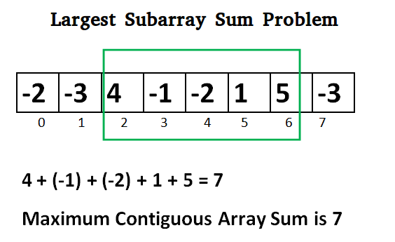

for (int i = 0; i < n; i++)

for (int j = i; j < n; j++) {

int sum = 0;

for (int k = i; k <= j; k++)

sum += a[k];

if (sum > max)

max = sum;

}

s